|  |  |  |
| --- | --- | --- |
| **Lyng Primary School P.E Knowledge Organiser** | | |
| **Topic: GYMNASTICS** | Year 2 | Spring 1 |





**Enquiry Questions**

* What should we do when performing a 3-point balance?
* What ways can we travel before completing a jump?
* How do we start and finish a roll correctly?
* Can we link travelling, jumps, rolls and balances together?
* How can we mount and dismount a bench safely?
* Can we perform a range of balances on a bench?

|  |  |
| --- | --- |
| **Key words** | |
| **Spelling** | **Definition** |
| Pencil Roll | Straight arms above your head, hands together, straight legs, and roll across the mat. |
| Point -Balance | A point balance is determined by a number given, i.e. 3 point balance using 3 body parts to balance. |
| Jumping | Being able to spring into the air off the floor or apparatus. |
| Landing | When returning to the ground safely, landing on your feet. |
| Pose | Performing a shape/letter before completing a roll, jump or balance. |
| Movements | How you travel before completing a jump or roll. |

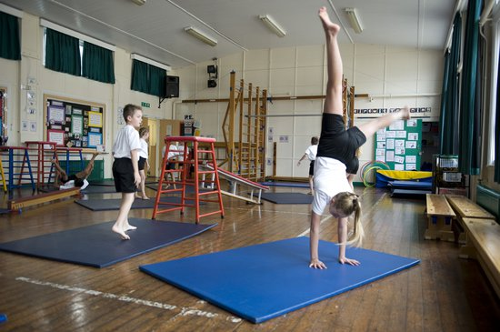

***“See, Believe & Achieve”***

**– Mav Levy**

|  |  |  |
| --- | --- | --- |
| **Lyng Primary School P.E Knowledge Organiser** | | |
| **Topic: GYMNASTICS** | Year 2 | Spring 1 |

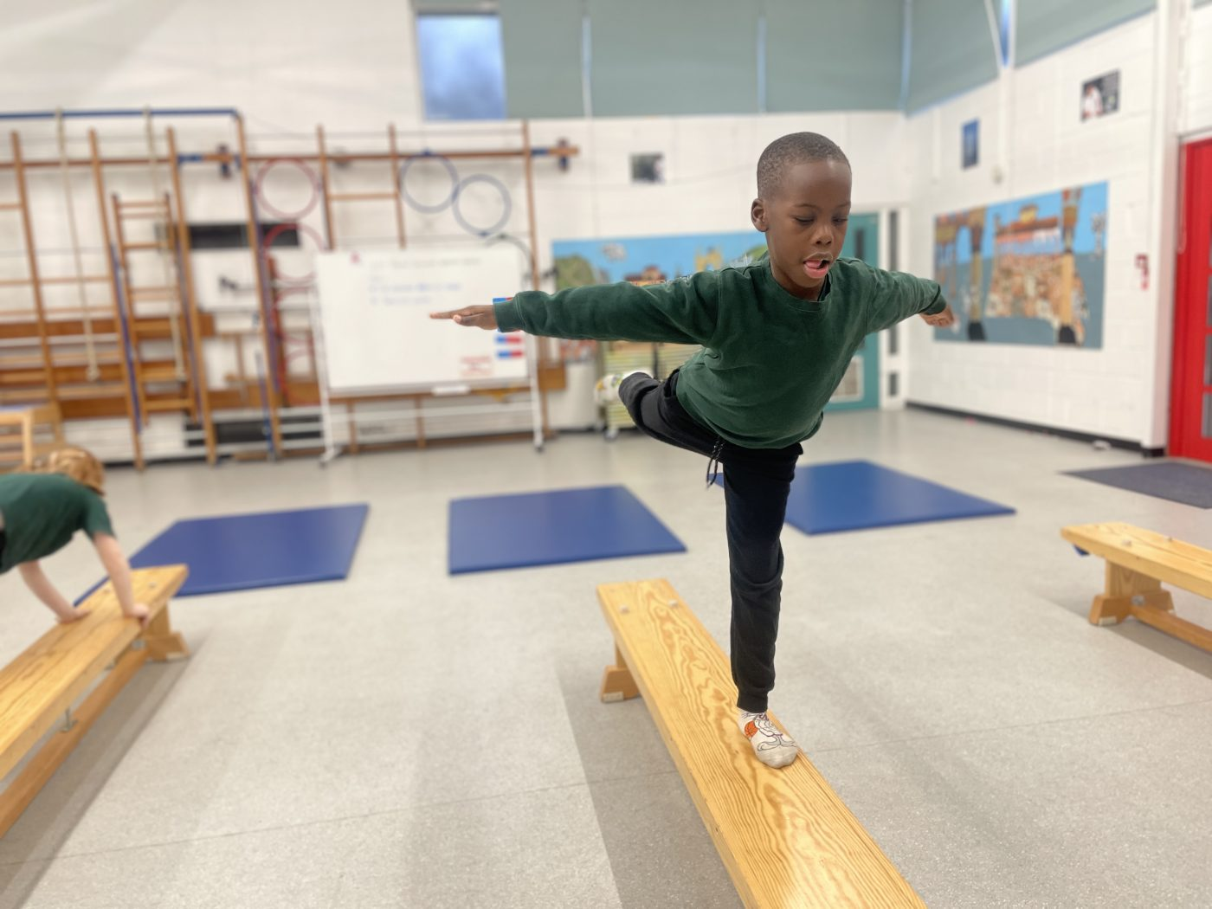

Learning Outcomes

* To be able to perform a variety of point balances.
* To be able to link travelling and jumping.
* To perform each roll with a pose at the beginning and at the end of a roll.
* To perform a sequence/routine of movements, rolls & balances.
* To be able to mount travel & dismount the bench safely
* To be able to perform a range of balances when using a bench.